**16 Week Practice Exam**

**NAME:**

**__ Solutions _______________**

**ALPHA:**

**_________________**

**SECTION:**

**_________________**

1. This is individual work.
2. **SHOW ALL WORK!**

### Write legibly to receive credit.

1. Turn in your equation sheet.

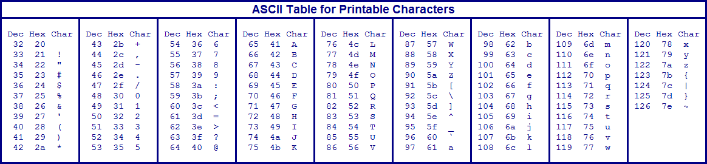



**SCORE:**

SCALE

>89.5%: 31337

**________/100**

79.5 – 89.5%: H@XX0R

69.5 – 79.5%: G33K

59.5 – 69.5%: $€RiPt K1DD13

<59.5%: n00b

Lesson 23- Error Detection

1. **[10] Encoding.** The following message will be encoded using the ***conventional*** Hamming coding parameters.

**Bit sequence: 0 1 0 0 1 0 1 1 0 0**

**Step 1.** In Table 1, Row 1, label each of the bit position numbers.

**Step 2.** In Table 1, Row 2, Identify the bit positions of the Hamming bits and the message bits (use *M* for message bit and *H* for Hamming bit).

**Step 3.** In Table 1, Row 3, transcribe the provided bit sequence into the message bit positions.

|  |  |  |  |  |  |  |  |  |  |  |  |  |  |  |  |
| --- | --- | --- | --- | --- | --- | --- | --- | --- | --- | --- | --- | --- | --- | --- | --- |
| 1 | Bit Position Number | 14 | 13 | 12 | 11 | 10 | 9 | 8 | 7 | 6 | 5 | 4 | 3 | 2 | 1 |
| 2 | Type of Bit Position | m | m | m | m | m | m | h | m | m | m | h | m | h | h |
| 3 | Codeword | 0 | 1 | 0 | 0 | 1 | 0 | h | 1 | 1 | 0 | h | 0 | h | h |

Table 1. Hamming Codeword.

**Step 4.** Solve for the value of the Hamming bits using ***conventional*** Hamming coding (express all the bit positions that contain a value of “1” as binary numbers, and XOR these binary numbers together).

2^n>=m+n+1; 2^4=16>=10 +4+1= 15

13= 1101

10=1010

7= 0111

6= 0110

0110 - hamming bits

**Step 5.** Finally, transcribe the Hamming bit values into Table 1, Row 3 to complete the codeword. Rewrite the completed codeword in Table 2 below.

|  |  |  |  |  |  |  |  |  |  |  |  |  |  |
| --- | --- | --- | --- | --- | --- | --- | --- | --- | --- | --- | --- | --- | --- |
| **0** | **1** | **0** | **0** | **1** | **0** | **0** | **1** | **1** | **0** | **1** | **0** | **1** | **0** |

Lesson 24- Wireless Technologies

1. [10] Answer the following topics on wireless:
2. What is spread spectrum? Name the 2 main types of spread spectrum.

The process of modifying an intelligence signal in such a way that its spectrum is spread over a

wide frequency range rather than being confined to a narrow single-channel bandwidth.

Frequency-hopping and direct-sequence SS.

1. What type of spread spectrum technique/s is/are used for WiFi.

802.11b: 2.4 GHz, 11 Mbps, **DSSS** ;

802.11a: 5.8 GHz; 54 Mbps, **OFDM;**

802.11g: 2.4 GHz, 54 Mbps, **OFDM**;

802.11n: 2.4 and 5.8 GHz, 300 Mbps, **OFDM/MIMO**

1. How are 2 or more stations using spread spectrum and sharing a common band identified and distinguished from each other?

The PSN signal is a unique binary code sequence used for each station operating over a

shared spectrum. It allows one station to be distinguished from another.

1. i)What low speed wireless technology ( of the 3 we investigated) gives the greatest range? ii)What technology gives the maximum speed over the greatest range?
2. ZigBee
3. IEEE802.11n- WiFi

Lesson 25 – Network Review

1. [10] For the boxes below, fill in the names of the layers for the TCP/IP - 5 layer reference model and then place the appropriate letter in the blank associated with the layer for the proper description of its services.

Layer5



Application d

Layer 4

Layer 3

Transport c

Network b



Layer 2



Data Link e

Physical



Layer 1 a

1. Provides a definition of mechanical and electrical standards for communication system
2. Concerned with transferring packets across a communication network
3. Responsible for end to end transfer of data
4. Primary function is to format and transfer files between communication message and the user’s software
5. Frames of data are transferred across a single link
6. [3] If an entire IP packet has 8096 bytes, how many Ethernet frames are required to transmit this packet?

An Ethernet frame has a maximum of 1500 bytes in the data portion, So 8096 /1500= 5.4 so we would need 6 frames.

Lesson 26: Internet Protocol

1. [2] The purpose of the *time to live* field in an IP header is to:
   1. Show the number of hops to the destination
   2. Prevent a packet from endlessly traversing the internet
   3. Translate a packet to classless routing (CIDR)
   4. Amplify the network mask
2. [2] Which one of the following is NOT a principle behind the design of the Internet Protocol?
3. user-defined
4. best-effort
5. unreliable
6. a) [4] Fill in the blanks: An IP address is 32 bits long. When expressed in dotted decimal form, every 8 bits form an octet. The integer value of a single octet can range from 0 to 255 .
   1. [2] In one sentence, state the purpose of a network mask. To extract the network ID from an IP address.
7. a) [4] Assume you are provided the IP address **128.32.14.2** and a network mask of

**255.255.254.0**. What is your network ID? (express in dotted decimal form)

IP Address: 128. 32.00001110.00000010

Mask: 255.255.11111110.00000000 (also = /23)

Net ID: 128. 32.00001110.00000000 **= 128.32.14.0**

* + 1. [2] Using the information given in Part (a) state the number of bits that can be used to assign host IP addresses.

32 bit long IP address – 23 bits used by the network ID = **9 bits** left for host portion

* + 1. [2] Using your answer from Part (b), determine how many valid host IP addresses you can assign on your network.

29 possible host bit combinations – 2 host addresses we cannot use (all zeros & all ones)

= **510 valid host IP addresses on my network**

* + 1. [3] Assume that host IP addresses are assigned sequentially from lowest to highest on your network. What is the last valid IP address that can be assigned to a host on your network? (express in dotted decimal form)

Net ID: 128.32.0000111**|**0.00000000

**(**23 NetID bits **|**9 host bits) Last Host ID: 128.32.0000111**|**1.11111110

Last Host ID: **128.32.15.254 (in dotted decimal)**

* + 1. [2] If your network administrator desired to create 29 subnets on your network, how many of your host bits would be used to accommodate this?

log2(29) = 4.85 ➔ 5 bits

Lesson 27 – Ethernet

1. **[4] Match column on the left with the description on the right**

|  |
| --- |
| a) Looks at MAC address and then forwards the frame on the correct port |
| b) Looks at incoming bits, regenerates them, and copies to its one other port |
| c) Piece of equipment with a unique address that translates bits to signals |
| d) Copies incoming bits to all other ports |

|  |
| --- |
| **Repeater b** |
| **Hub d** |
| **Switch a** |
| **Network Interface Card c** |

1. [4] Answer the following questions about the Address Resolution Protocol:
2. The Address Resolution Protocol works at which two layers? Data Link

Network

1. The Address Resolution Protocol consists of which two types of messages? ARP Request

ARP Reply

1. (Y/N) Can an ARP Reply be sent without an ARP request? Yes
2. When a sender wants to find out what MAC address corresponds to an IP address, to which MAC address would she send an ARP request to simultaneously query all network hosts? (Check the appropriate answer)

 0.0.0.0

     ff:ff:ff:ff:ff:ff

 255.255.255.255

 00:00:00:00:00:00

Lesson 28 – Routing Tables

1. [10] Given the following diagram:

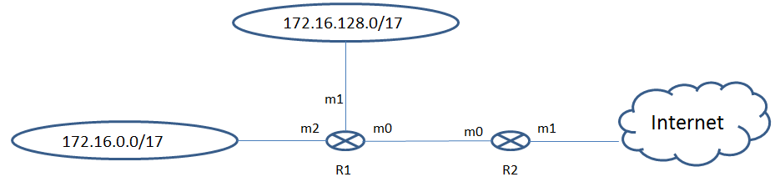

Use the technique of Address Aggregation to create the Routing Table with the minimum number of entries.

|  |  |  |
| --- | --- | --- |
| Network 1 Range | - 172.16.0.0 | -> 172.16.127.255 |
| Network 2 Range | - 172.16.128.0 | -> 172.16.255.255 |
| Combined Range | - 172.16.0.0 | -> 172.16.255.255 |
| Aggregated Address | - 172.16.0.0/16 |  |

|  |  |  |  |
| --- | --- | --- | --- |
| Mask | Network Address | Next Hop | Interface |
| /16  /0 | 172.16.0.0  0.0.0.0 | R1  ----- | m0 m1 |

1. [6] Your IP Address is **10.226.58.15/24**. How would you send messages to the host **10.226.58.229**? (Show work for full/partial credit)
2. This host is unreachable because the IP address is not within my network range.
3. Through the first Next Hop router in my routing table with a /24 mask.
4. Via my default router since the specific network address is not in my routing table.
5. Direct delivery within LAN after verifying ARP information.
6. Give up and use UPS.

Source IP – 10.226.58.15/24 -> Network Address – 10.226.58.0 Destination IP – 10.226.58.15/24 -> Network Address – 10.226.58.0

Both hosts on same network -> Direct Delivery within LAN

Lesson 29 – Routing Table Exploitation

1. [4] In one sentence, what is the naive assumption made by routers in the routing algorithms they use which makes a Man-In-The-Middle (MITM) attack possible?

**The assumption is that each router can trust the information that other routers are sending it.**

1. 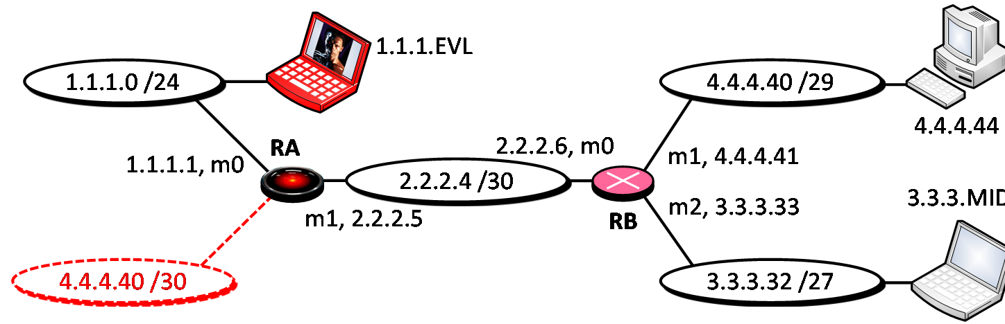An attacker is located on the 1.1.1.0 /24 network and wants to prevent midshipmen from reaching a website at 4.4.4.44. The attacker takes control of Router A and creates a false network from Router A with a more specific network prefix of 4.4.4.40 /30 which he hopes will direct the midshipmen’s traffic away.
   1. [8] Construct the routing table for Router B.

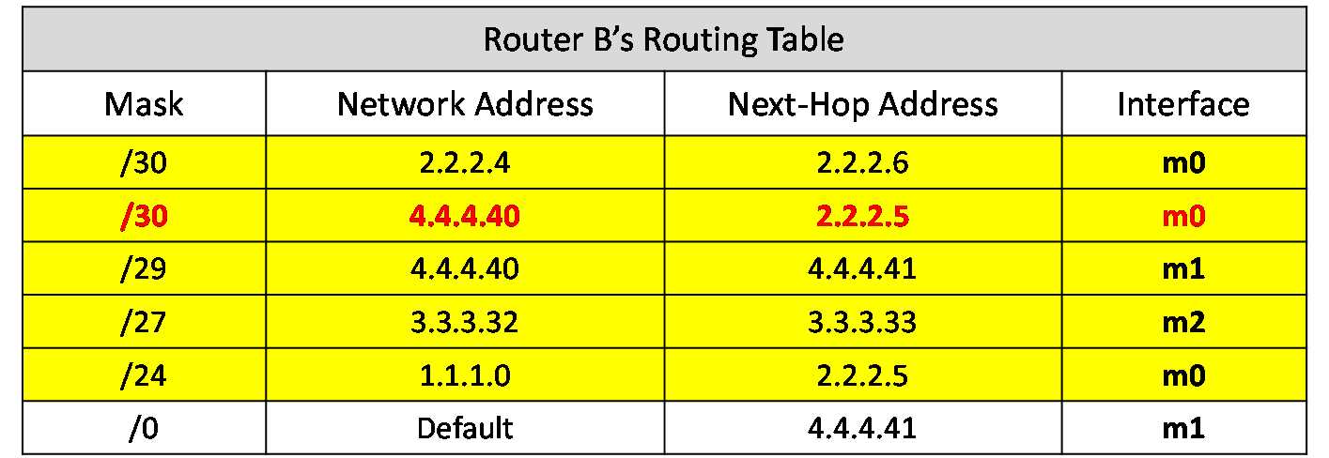

* 1. [4] Complete the binary conversions in the table below. Then circle the Network ID bits in each case.

|  |  |  |  |  |  |  |  |  |  |  |  |  |  |  |  |  |  |  |  |  |  |  |  |  |  |  |  |  |  |  |  |  |
| --- | --- | --- | --- | --- | --- | --- | --- | --- | --- | --- | --- | --- | --- | --- | --- | --- | --- | --- | --- | --- | --- | --- | --- | --- | --- | --- | --- | --- | --- | --- | --- | --- |
| Target’s Network | 4 | | | | | **.** | | | 4 | | | | | **.** | | | 4 | | | | | **.** | | | 40 | | | | | | | |
| 0 | 0 | 0 | 0 | 0 | 1 | 0 | 0 | 0 | 0 | 0 | 0 | 0 | 1 | 0 | 0 | 0 | 0 | 0 | 0 | 0 | 1 | 0 | 0 | 0 | 0 | 1 | 0 | 1 | 0 | 0 | 0 |
| Target’s IP Address | 4 | | | | | **.** | | | 4 | | | | | **.** | | | 4 | | | | | **.** | | | 44 | | | | | | | |
| 0 | 0 | 0 | 0 | 0 | 1 | 0 | 0 | 0 | 0 | 0 | 0 | 0 | 1 | 0 | 0 | 0 | 0 | 0 | 0 | 0 | 1 | 0 | 0 | 0 | 0 | 1 | 0 | 1 | 1 | 0 | 0 |
| Attacker’s Lie | 4 | | | | | **.** | | | 4 | | | | | **.** | | | 4 | | | | | **.** | | | 40 | | | | | | | |
| 0 | 0 | 0 | 0 | 0 | 1 | 0 | 0 | 0 | 0 | 0 | 0 | 0 | 1 | 0 | 0 | 0 | 0 | 0 | 0 | 0 | 1 | 0 | 0 | 0 | 0 | 1 | 0 | 1 | 0 | 0 | 0 |

* 1. [4] Will the attacker be successful in redirecting the midshipmen’s traffic? (Circle one)
     1. **Yes**, the attacker’s fake network has a longer mask.
     2. **Yes**, the attacker’s fake network is a shorter path.
     3. **No, the network ID bits for the fake network do not match the target’s network ID bits.**
     4. **No,** the attacker’s fake network will be towards the bottom of the

routing table.